**Enable Monitoring for MongoDB on AWS EC2**

**1. Install and Configure CloudWatch Agent**

First, ensure the **AWS CloudWatch Agent** is installed and running on your EC2 instance.

**Step 1: Install CloudWatch Agent**

For **Ubuntu**:

sudo apt update

sudo apt install -y amazon-cloudwatch-agent

**Step 2: Configure CloudWatch Agent**

Create a configuration file for monitoring **CPU & Memory**:

sudo tee /opt/aws/amazon-cloudwatch-agent/bin/config.json <<EOF

{

"agent": {

"metrics_collection_interval": 60,

"logfile": "/opt/aws/amazon-cloudwatch-agent/logs/amazon-cloudwatch-agent.log"

},

"metrics": {

"aggregation_dimensions": [["InstanceId"]],

"metrics_collected": {

"cpu": {

"measurement": ["cpu_usage_active"],

"metrics_collection_interval": 60

},

"mem": {

"measurement": ["mem_used_percent"],

"metrics_collection_interval": 60

}

}

}

}

EOF

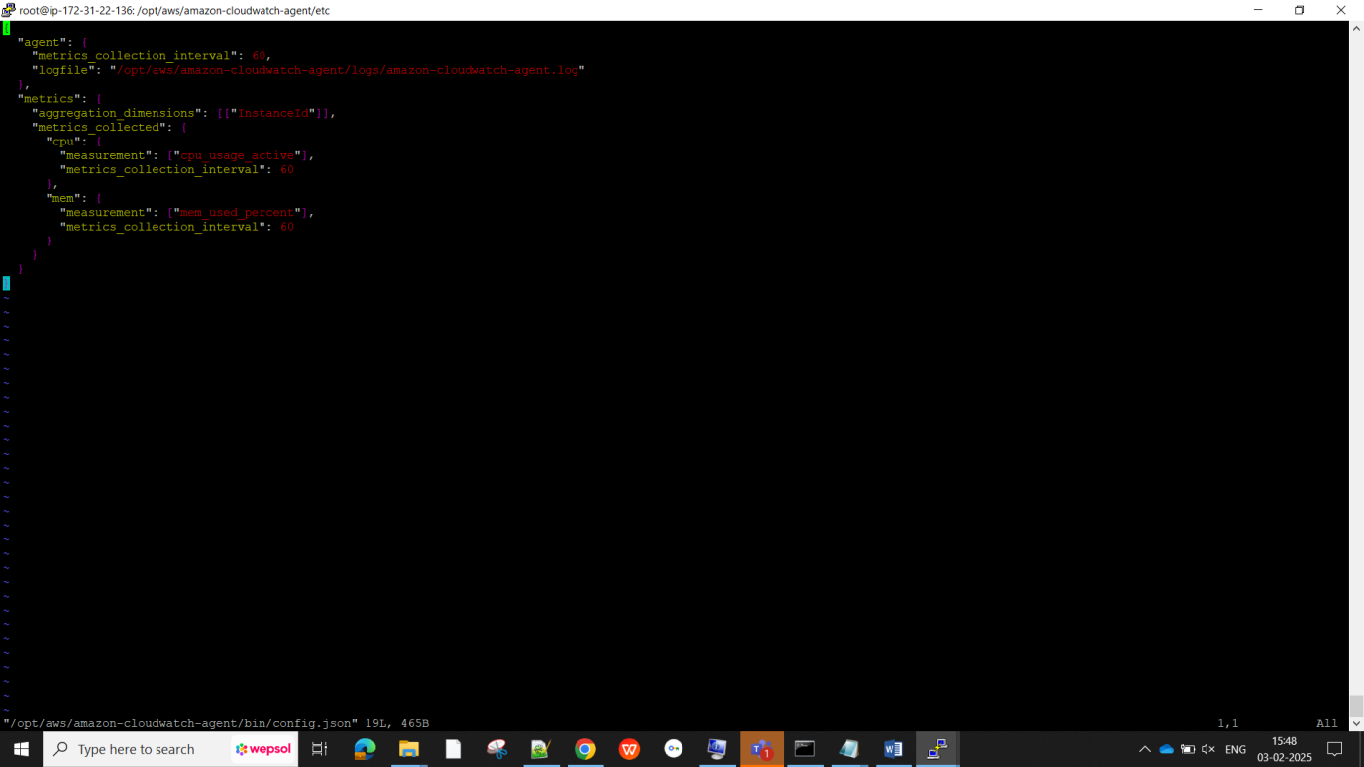

**Step 3: Start the CloudWatch Agent**

sudo amazon-cloudwatch-agent-ctl -a fetch-config -m ec2 -c file:/opt/aws/amazon-cloudwatch-agent/bin/config.json -s

Check agent status:

sudo systemctl status amazon-cloudwatch-agent

If the service is **not running**, start it:

sudo systemctl start amazon-cloudwatch-agent

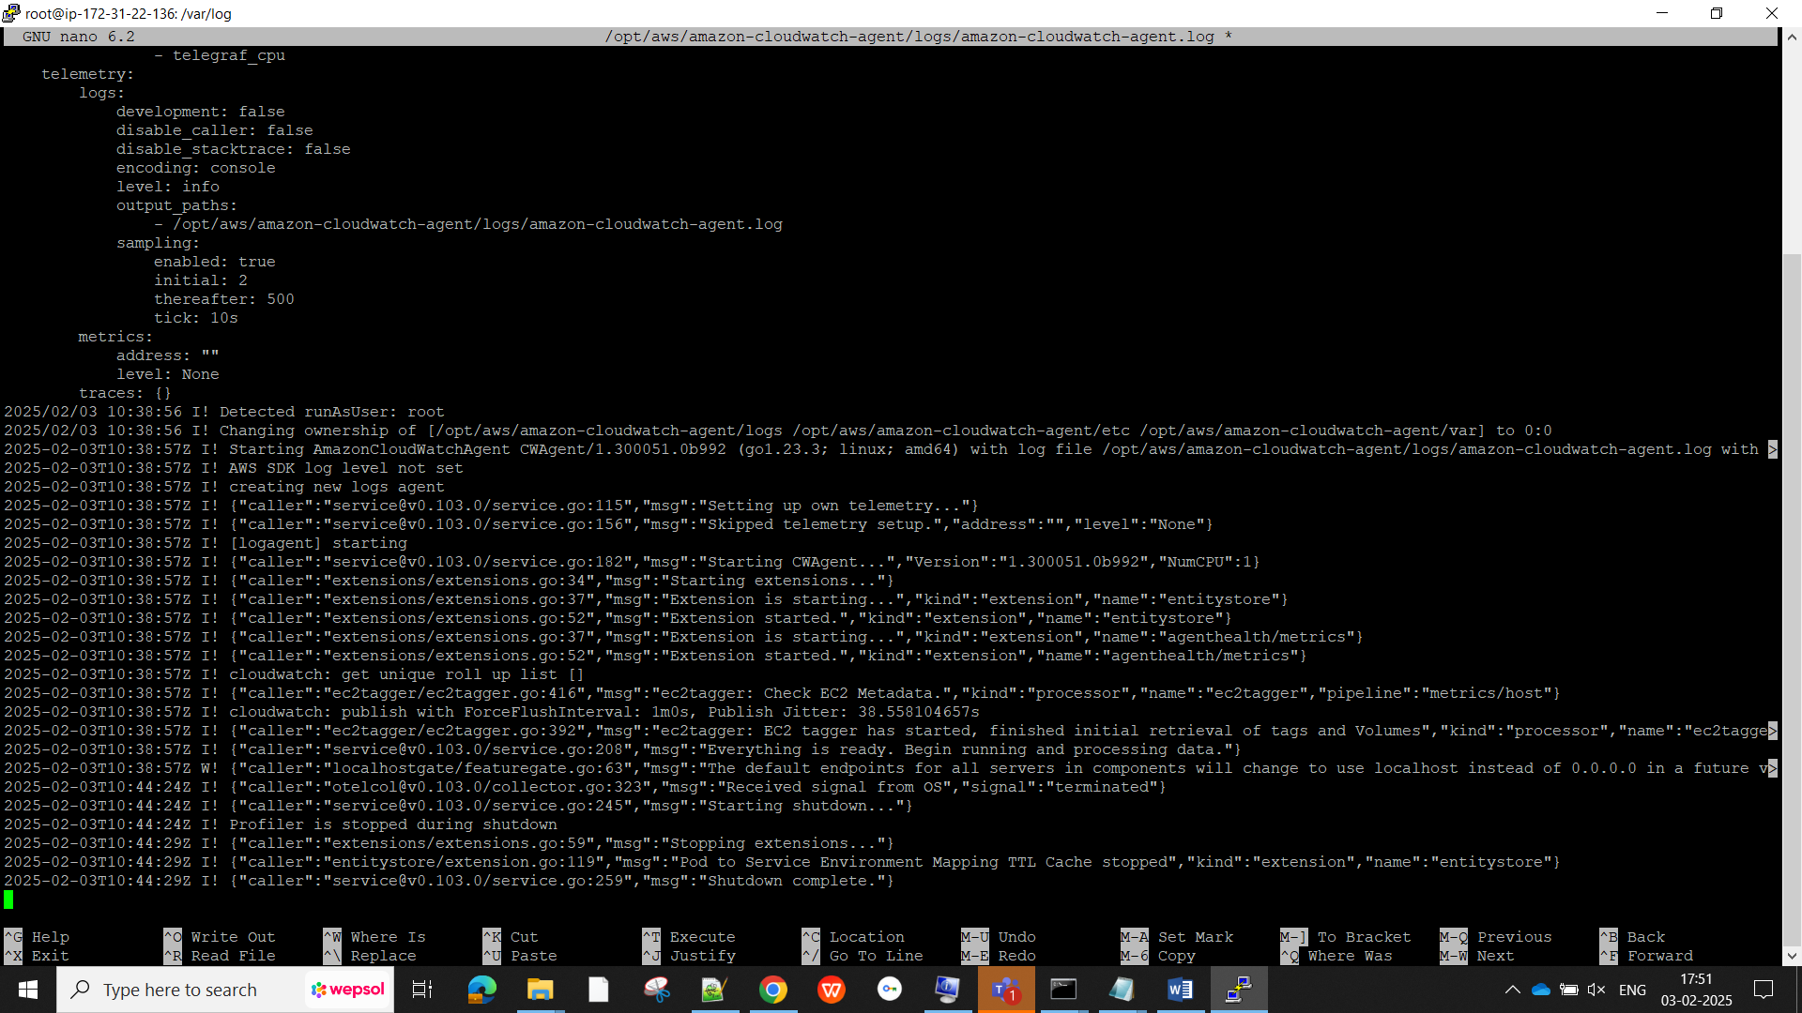

**2. Enable MongoDB Error Logging to CloudWatch Logs**

MongoDB logs are usually stored in /var/log/mongodb/mongod.log. We need to send these logs to AWS CloudWatch.

**Step 1: Create a CloudWatch Logs Configuration**

sudo tee /opt/aws/amazon-cloudwatch-agent/bin/log-config.json <<EOF

{

"logs": {

"logs_collected": {

"files": {

"collect_list": [

{

"file_path": "/var/log/mongodb/mongod.log",

"log_group_name": "MongoDB-Logs",

"log_stream_name": "{instance_id}",

"timezone": "UTC"

}

]

}

}

}

}

EOF

**Step 2: Apply the Configuration**

sudo amazon-cloudwatch-agent-ctl -a fetch-config -m ec2 -c file:/opt/aws/amazon-cloudwatch-agent/bin/log-config.json -s

**Step 3: Restart the CloudWatch Agent**

sudo systemctl restart amazon-cloudwatch-agent

**3. Verify CloudWatch Metrics & Logs**

* **Check Metrics**:
  + Go to AWS Console → **CloudWatch** → **Metrics** → **EC2** → View **CPU and Memory Usage**.
* **Check MongoDB Logs**:
  + Go to **AWS Console → CloudWatch → Log Groups**.
  + Look for **MongoDB-Logs** and check for MongoDB errors.

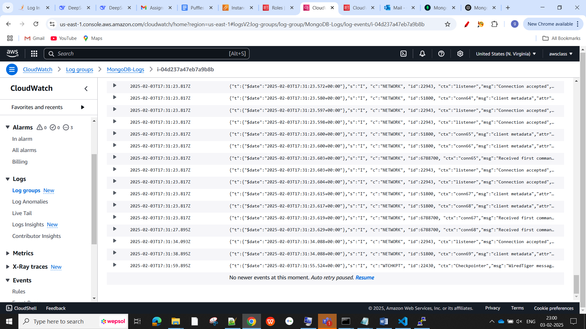

**4. Ensure IAM Role is Attached to EC2**

If CloudWatch is **not receiving data**, make sure your EC2 instance has the correct IAM role attached:

1. **Go to AWS IAM Console** → **Roles**.
2. Create or edit an **EC2 IAM Role**.
3. Attach **CloudWatchAgentServerPolicy**.
4. Assign the IAM role to your **EC2 instance** under **Actions → Security → Modify IAM Role**.

